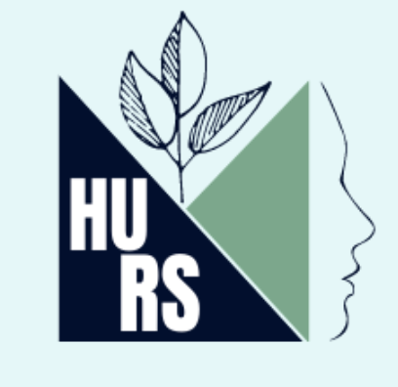

HURS Schedule 2024

9:00am: Breakfast
9:30am: Opening Remarks
9:45am: Art, Attention, and Media Part I (45 minutes, 15 minutes per presentation)
- Grace Kennedy — College Decisions
- Lee Ernest — Clover
- Krista Mitchell — Home by Sundown
  - Moderator: Rylee Thomas
11:00am: Art, Attention, and Media Part II (30 minutes, 15 per presentation)
- Rylee Thomas — The Ghostly Dynasty: Victim-Blaming, the Gothic Novel, and the Modern True Crime Drama
- Katherine Jimenez — The Maternal Ghost: Studying the Mother in Gioconda Belli’s “The Inhabited Woman”
  - Moderator: Breanna Bonner
Noon: Lunch
1:00pm: Environment, Place, and Legacy (30 minutes, 15 per presentation)
- Makenzie Smith — Reconstructing Art and Evidence: Forensic Architecture in Institutional Settings
- Daniel Milovic — Environmentalism Cinema in the Climate Era
  - Moderator: Grace Kennedy
2:00pm: Humanities Education (30 minutes, 15 per presentation)
- Rebecca Andersen — The Voices of the People Unit Plan
- Thomas Sarbunan — Enhancing the Empowerment of Coastal Communities via English Education
  - Moderator: Rylee Thomas
2:45pm: Keynote Speech by Professor Anna Mae Duane (25 minutes plus Q&A)
4:15pm: Collective Memory and Social Movements (45 minutes, 15 per presentation)
- Jenna Ulizio — The Dividing Lines: Narration, the Post Generation, and Hiding in Memory
- Madison Bigelow — Poetry of the Institution: Proposing the Examination of an “Institutional Poetics”
- Breanna Bonner — The Space Between Black and Liberation: A Digital Exploration of Intersectional Invisibility
  - Moderator: Grace Kennedy
5:30pm: Reception

